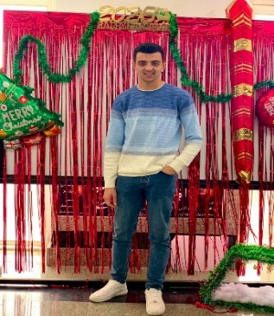 |  |  |  |  | Omar Eissa Ibrahim Wahdan  - | +201004874828 / +201120280237 | omareissawahdan@gmail.com | www.linkedin.com/in/omareissawahdan  Motivated and ambitious Computer Science student at El Shorouk Academy with hands-on experience in AI model training, IT support, and customer service. Skilled in programming, data annotation, network troubleshooting, and professional communication.

Experience
jan 2025 - Mar 2025 |  |  |  | Customer Service Representative (Call Center Agent)  Vodafone Egypt – Cairo, Egypt  Handled customer inquiries, billing issues, and technical complaints via inbound/outbound calls.  Maintained customer satisfaction rate above 90% during employment.
Aug 2025 - SEP 2025 |  |  |  | IT Support Specialist (Internship)  NTI & ITIDA Training Program – Cairo, Egypt  Assisted in troubleshooting network connectivity, hardware, and software issues.  Documented technical problems and solutions, improving efficiency of IT support processes.

Education
sep 2024 - jun 2028 |  |  |  | El Shorouk Academy – Faculty of Computer Science  Bachelor’s Degree in Computer Science (Expected Graduation: 2028)  Currently a 2nd-year student specializing in Computer Science.  Completed academic projects in programming, networking, and research writing.  Achieved excellent academic performance with strong skills in teamwork and presentations.
Skills |  |  |  |  |  |  | Activities
- Strategic Planning  - Decision-Making  - Team Leadership & Management |  |  |  |  |  |  | Arabic (Native)  English (Excellent)  French (Good)

